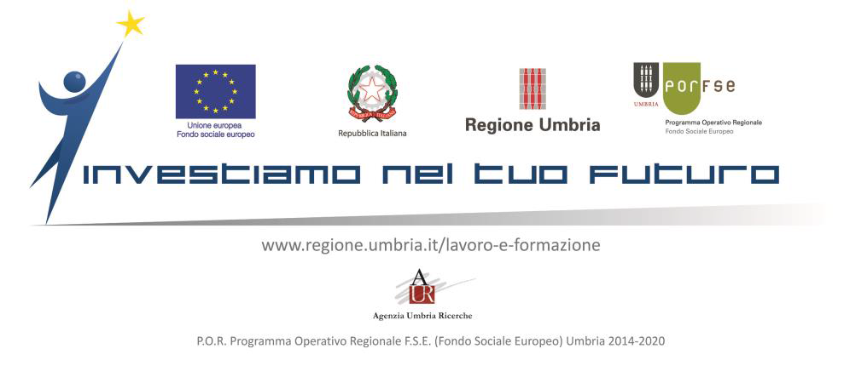

Region of Umbria– Brussels Office invites you to the final event of

***2e7894_d2a3bca0960777b4121410c7fe0e14f6.png***

******

***(Entrepreneurship at School)***

Pilot action to spread the enterprise culture of young people in the schools

Funded by the European Social Fund (Umbria Region 2014-2020)

13th October, 09.30 - 13.00

Region of Umbria - Brussels Office  
 14 Rond Point Schuman, 1040 Brussels

[HOW TO FIND US](https://www.google.be/maps/place/Rond-point+Robert+Schuman+14,+1000+Bruxelles/@50.8428531,4.3820101,17z/data=!3m1!4b1!4m5!3m4!1s0x47c3c4a1c1d35edf:0x1f66d49e769f6b6!8m2!3d50.8428531!4d4.3841988?hl=en)

09:00 **Registration**

09:30 **Host welcome**

**Mrs Anna Ascani** Head of Umbria Region Brussels Office and Director of Agenzia Umbria Ricerche

**Moderator: Mrs Anna Ascani**

09:40 **Keynote Speech**

**Mrs Maria Palladino** European Commission DG EAC — Directorate-General for Education, Youth, Sport and Culture Dir C — Innovation, International Cooperation and Sport - Innovation and EIT

***European policies for Education to Entrepreneurship***

**Mr Bruno Cortese**  European Commission DG EMPL — Directorate-General for Employment, Social Affairs and Inclusion Dir E — Skills 4. Italy, Denmark, Sweden

***The role of the European Structural and Investment Funds in the Education to Entrepreunership***

**Regional experiences and exchange of best practices**

10:10 **Mrs Noelia Cantero** Business Manager of EARLALL (European Association of Regional and Local

Authorities for Lifelong Learning)

***European networking in entrepreneurship education: an added value – Experiences and best***

***practices among EARLALL’s members***

# 10:25 Mr Daniele Adanti Researcher AUR – Agenzia Umbria Ricerche

## Presentation of the book “Cultura d’impresa e imprenditorialità nella scuola”

## (Entrepreunership culture and entrepreunership in the schools)

The best practices of the pilot action “A scuola d’impresa”

10:40 ***Presentation of the Business ideas from the finalist student teams in the framework of the national competition “[A scuola d’impresa](http://www.scuolaimpresa.net/progetto)”- Year 2016/2017***

“*Progrape”* Istituto Professionale “Orfini” - Foligno

*“The cutter”* Istituto d’istruzione superiore “Giordano Bruno” - Perugia

*“Umbria on paper”* Istituto Professionale “Orfini” - Foligno

*“Sweet Hemp”* Istituto d’istruzione superiore “Cavour- Marconi\_Pascal”- Perugia

*“PasTiamo”* Istituto Tecnico Economico Tecnologico “A. Capitini” - Perugia

11:50 **Mr Alberto Follador** Region of Veneto – Brussels Office

***Best practices in the field of the dual-training systems - learning and working – and start up.***

***Project: “FITT! Forma il tuo futuro”***

**Interactive workshop**

12:05 **Mrs Maria Palladino**

***Young entrepreuners in action (students are the lead!)***

**Conclusions**

12:35 **Mrs Anna Ascani/Experts**

***Closing remarks***